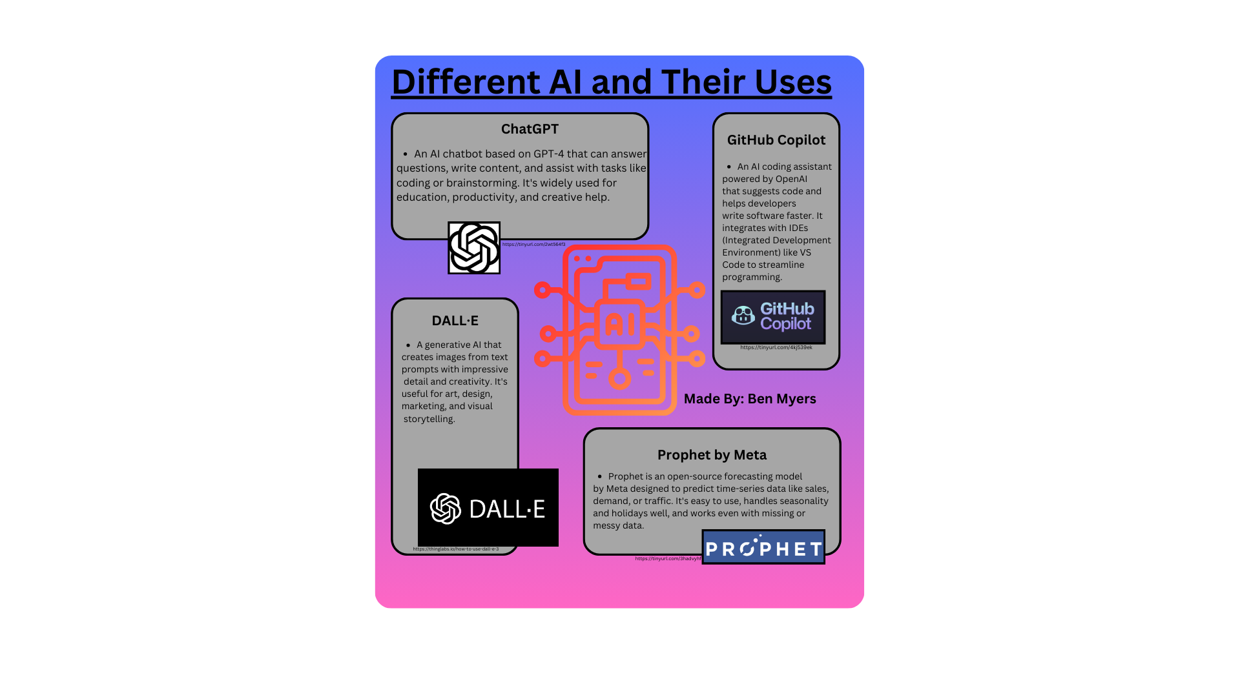
Different AI and Their Uses
ChatGPT
• An Al chatbot based on GPT-4 that can answer questions, write content, and assist with tasks like coding or brainstorming. It's widely used for education, productivity, and creative help.
https://tinyurl.com/2wt564f3
DALL'E
• A generative Al that creates images from text prompts with impressive detail and creativity. It's useful for art, design, marketing, and visual storytelling.
GitHub Copilot
• An Al coding assistant powered by OpenAl that suggests code and helps developers write software faster. It
integrates with IDEs (Integrated Development Environment) like VS Code to streamline
programming.
GitHub Copilot
https://tinyurl.com/4kj539ek
DALL-E
Made By: Ben Myers
Prophet by Meta
• Prophet is an open-source forecasting model by Meta designed to predict time-series data like sales, demand, or traffic. It's easy to use, handles seasonality and holidays well, and works even with missing or messy data.
https://tinyurl.com/3hadvyht
PROPHET

