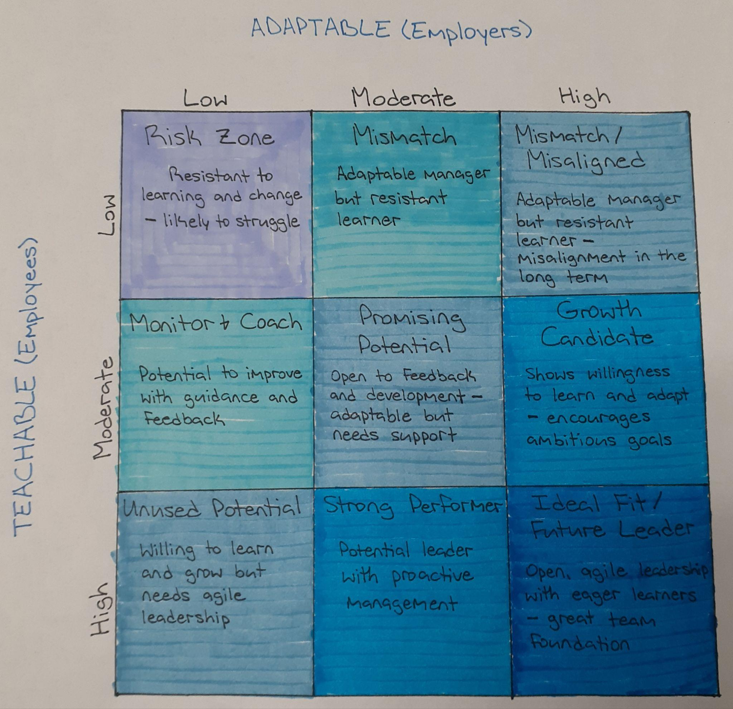
By: MiKayla Mahramas
Email: mikaylamahramas@gmail.com

