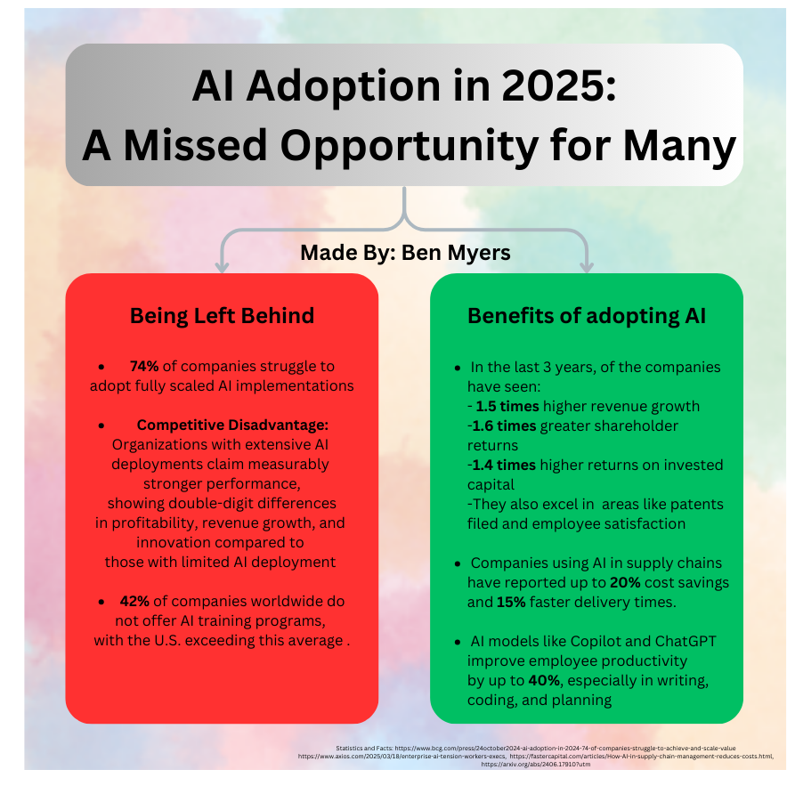
Al Adoption in 2025:
A Missed Opportunity for Many
Made By: Ben Myers
Being Left Behind
Benefits of adopting Al
74% of companies struggle to adopt fully scaled Al implementations
Competitive Disadvantage: Organizations with extensive Al deployments claim measurably
stronger performance, showing double-digit differences in profitability, revenue growth, and innovation compared to
·
those with limited Al deployment
42% of companies worldwide do not offer Al training programs,
with the U.S. exceeding this average.
• In the last 3 years, of the companies have seen:
- 1.5 times higher revenue growth -1.6 times greater shareholder returns
-1.4 times higher returns on invested capital
-They also excel in areas like patents filed and employee satisfaction
• Companies using Al in supply chains have reported up to 20% cost savings and 15% faster delivery times.
• Al models like Copilot and ChatGPT improve employee productivity by up to 40%, especially in writing, coding, and planning
Statistics and Facts: https://www.bcg.com/press/24october2024-ai-adoption-in-2024-74-of-companies-struggle-to-achieve-and-scale-value
https://www.axios.com/2025/03/18/enterprise-ai-tension-workers-execs, https://fastercapital.com/articles/How-Al-in-supply-chain-management-reduces-costs.html,
https://arxiv.org/abs/2406.17910?utm

